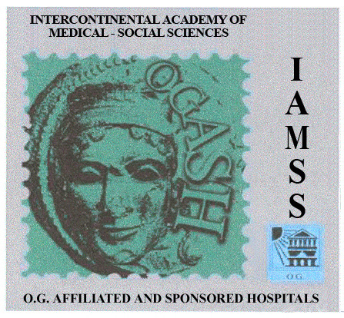

Awarded Gold paratherapeutic Complexes

Gold Flex Complex is highly effective natural paratherapeutic means that is the source of nutrient fibers that deficiency amounts 80% of modern men's ration. Gold cleans complex regulates motor function of bowels, absorbs and educes from organism toxins, radionuclides, salts of heavy metal, slags and surplus mucus developed as a result of metabolism. Reduces content of cholesterol in blood, development of colon disease, fatness, invasion of worm and enteric infection. Gold cleans complex protects and regenerates all sections of bowels' mucous membrane. Filling and strengthening gut organisms. Reduces intoxication, at the time of pregnancy of toxicosis.
Side effect: is not recommended upon individual intolerance of component parts.
Administration: V2 -2 teaspoon in a day, by gradual increase of dosage and number of taking it.
Keep out of reach of children. Store in dry and cool place, away from sunlight.
Gold Osteo Complex is highly effective natural paratherapeutic means, where minerals and microelements are provided in the form of amino acids' chelate. It maintains and regenerates physiological function of bone tissue and at the same time hampers formation of calcificates in vessels, kidneys, joints and spine disks. Gold Osteo Complex is especially effective upon prophylaxis and rehabilitation of fractures and various etiology osteopathy, also when having various problems and osteoporosis related to mineral metabolism.
Administration: 1-4 pills at the time of eating within the daytime according to the age, health and individual requirement.
Gold E-Complex is highly effective paratherapeutic means, composed of natural 10 isomers of tokopherols and complex of tokotrienels with unique antioxidant features, at the same time provide conation of tokopherols. Gold E-Complex improves bleeding and circulation, hinders formation of thrombus, regenerates elasticity of walls of capillars and vessels and facilitates normalization of immune, nervous and muscular system. It is essential for the regulation of hormonal and reproductive systems. It is very important to take when suffered from diabetes for the prophylaxis and rehabilitation of vascular problems.
Administration: 1- capsule at the time of eating. If it is essential dosage may be increased after consulting doctor.

