
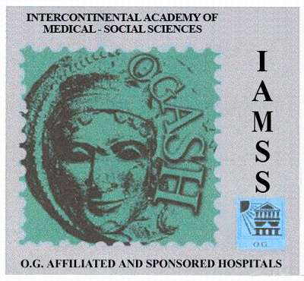
MPISRL IAMSS OGASH
Consensus
www.gestosis.ge/eng/26_8.php

OGASH Academy Venus Georgia
104,Tsinamzgvrishvili Street, Tbilisi, Georgia
Tel:(995 32) 910158 Mob: (899) 26 69 67 . e-mail: tschagia@yahoo.com
www.gestosis.ge/eng/26_3.php _____________________________________________________________________________________________________________________
@
protokolis # wyvilTa imunoserologiuri gamokvleva

pacienti coli asaki

pacienti qmari asaki TariRi
 | ABO/RH sisxlis jgufi da rezus  faqtori |  | rezus CcDdEe  fenotipi | Mminoruli antieritrocituli antigenebi  MN Kel1 Jka Jkb Fya
qali ( orsuli, araorsuli) |  |  | V
mamakaci
izohemagglutininebi (qalis SratSi)  anti -A  anti-B | Nnorma titrebSi  < 1:64  <1:32 | Sedegi  titri |  | imunuri antisxeulebi  anti-AA  anti- B | Nnorma  0  0
sruli antieritrocituli antisxeulebi Ig M (qalSi)
arasruli antieriTrocituli antisxeulebi Ig G ( qalSi) |  | A
anti- HLA antisxeulebi( qalSi) |  | A
Aspermoimobilizirebuli da citotoqsiuri antisxeulebi (qalSi)
HLA I daIIklasis antigenebis mixedviT wyvilTa HLA histoSeTavsebis indeqsi | <50

MPISRL IAMSS OGASH
© Tsisana Chagiashvili General Expert of Consensus, Main Expert of IAMSS OGASH MPSRL named after Dr.Ernst Rippmann
laboratoriuli medicinis saerTaSoriso eqperti, saerTaSoriso premiebis laureati www.gestosis.ge/eng/26_8.php biol. mec. doqtori cisana CagiaSvili ©

