
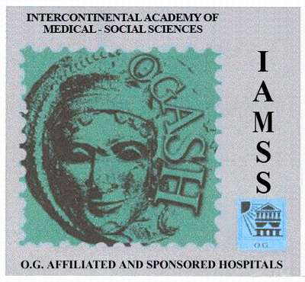
MPISRL IAMSS OGASH
Consensus

Venus Georgia
104,Tsinamzgvrishvili Street, Tbilisi, Georgia
Tel:(995 32) 910158 Mob: (899) 26 69 67 . e-mail: tschagia@yahoo.com
____
_____________________________________________________________________________________________________________________
@
# Immunoserological assay in couples with high risk misscarriage

patient female age gestation /

patient male age
Ddate
IMMUNOSEROLOGICAL ASSAY | ABO/RH testing |  | Rhesus PhenotypeCcDdEe | Minor RBC antigen  MN Kel1 Jka Jkb Fya
Pregnant women |  |  | V
Man
Izohemaglutinine antibody  ( Wonan)  anti -A  anti-B | NORM titer  < 1:64  <1:32 | RESULT titer |  | Immune antibody  anti-AA  anti- B | 0  0
Complete RBC antibody Ig M (Woman)
Incomplete RBC antibody IgG (Woman) |  | A
Anti-HLA antibody (Woman) |  | A
Spermimmobilizing and spermcytotoxic antibody (Woman)
HLA Histocompatibility Index Class I  Class II | <50

Tsisana Chagiashvili
General Expert of Consensus MPISRL
IAMSS OGASH

Main Expert of IAMSS OGASH MPSRL named after
Dr. Ernst Rippmann

