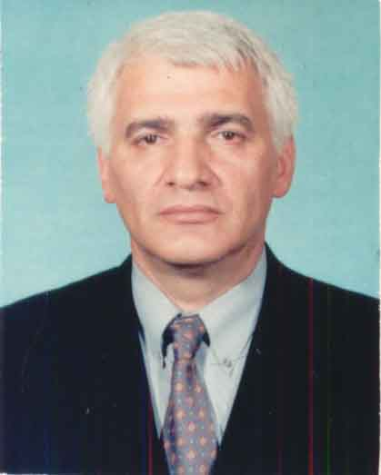

CV
National Expert
Georgia OGASH Subcommittee

Elguja (patronymic: Solomon) Tartarashvili was born on September 29, 1950.
In 1978, he graduated from Tbilisi State Medical Institute with honours, majoring in medical business.
In 1978-1980, he passed clinical residency at the obstetric-gynecological sub-faculty of the pediatric faculty of the mentioned institute.
1982-1985-Post-graduate course.
1985-Assistant of the same sub-faculty.
From 1989 member of Organisation ''Gestosis", International Society for the study of pathophysiology of pregnancy;
1989-he defended a thesis on "Protective medical regimen with drug galvanoiontophoresis, as a method of optimization of pregnancy control tactics in patients with mitral valvular disease with the purpose of taking the degree of candidate of science.
1994-2002-was a head of pregnancy pathology department at the 2nd maternity hospital.
In 1999, he defended a thesis on "fetal hypoxia; clinic, diagnostics, treatment, prophylaxis" with the purpose of taking the degree of Doctor of Medicine.
In 2002, he was awarded the research and educational title of associate professor with Obstetric-gynecological specialty.
From 2005, he has been a director of tbilisi # 2 maternity hospital in medical branch. He has published 42 scientific proceedings, includung 5 methodical recommendations, 3 rationalization proposals, 2 inventions.

