PRE-ECLAMPSIA AND ECLAMPSIA - WHEN SHOULD ANTI-CONVULSANT DRUGS BE USED?

Kornman LH
The Royal Women’s Hospital
Melbourne

There is little doubt now that magnesium sulphate is the drug of choice in eclampsia. The large Collaborative trial published in 1995 ¹ provided the necessary evidence, based on almost 1700 women who were randomised to either a magnesium sulphate versus phenytoin arm, or a magnesium sulphate versus diazepam arm. Women in the magnesium sulphate arm had a 52% lower chance of recurrent seizures than those given diazepam and a 67% lower chance when compared with phenytoin. There was a trend towards lower maternal mortality in the magnesium sulphate arms. In this study, women were entered if there was a clinical diagnosis of an eclamptic fit. The drugs were administered regardless of the time since the original fit, and any previous drugs which had been administered. This trial used a magnesium sulphate regimen of a bolus of 4g I-V over 5 minutes, and then 1g/hour for 24 hours. Recurrence of seizures was treated with a further 2-4g I-V infused over five minutes.

Magnesium sulphate would also appear to be the drug of choice in preventing pre-eclampsia progressing to eclampsia. The Magpie study² involved over 10,000 women and concluded that magnesium sulphate halves the risk of eclampsia and probably reduces maternal mortality. The Cochrane database also supports the use of magnesium sulphate in the prevention of pre-eclampsia ³. In 6 trials involving 11,444 women, when compared to placebo or no treatment, it halved the risk of eclampsia and probably reduced the risk of maternal death. Magnesium sulphate was also found to be superior to both phenytoin and nimodipine (a cerebral vasodilator).

The timing of magnesium sulphate is straightforward in women with eclampsia – it is when they reach medical attention. However, the timing of magnesium sulphate treatment in pre-eclampsia is more difficult. In deciding the most appropriate time and group in which to commence magnesium sulphate therapy, the following issues need to be addressed: the magnitude of the problem, the ability to predict those women who will progress to eclampsia (largely related to the antecedents of eclampsia), the risks versus the benefits of the treatment to both mother and baby, the logistic /staffing issues related to the use of the drug.

Magnitude Of The Problem
Eclampsia occurs in approximately 1 in 2000 births in the UK, 1 in 100 births in low-income countries and 1 in 1700 births in middle-income countries³. Pre-eclampsia is a far more common condition, with an incidence of 5-8% quoted for the USA⁴, 5-6% for the UK⁵.

Prediction Of Eclampsia
The very name - pre-eclampsia – suggests that this is the condition which precedes eclampsia. However, examining the data it becomes obvious that eclampsia is not always a step-wise progression from pre-eclampsia, particularly in developed countries. The study by Katz et al ⁶ , reviewed cases of eclampsia from 2 institutions in the USA between 1987 and 1999 and found that eclampsia preceded the diagnosis of pre-eclampsia in 32 of 53 cases. Only nine cases in their series had potentially preventable eclampsia. The review of eclampsia in the UK in the year 1992 by Douglas and Redman⁷ found that 38% of cases were ‘unheralded’ by pre-eclampsia. They attributed this apparent change from earlier studies, to a relative reduction of classical eclampsia (ie preceded by pre-eclampsia) due to screening and treatment in antenatal care, resulting in a relative increase in atypical eclampsia.

Maternal Risks Of Magnesium Sulphate
(Data from the Cochrane Review³⁾
Serious risks:
- Respiratory depression occurring in 1% of women (compared to 0.5% in the placebo group)
- Overdose has been reported
Lesser risks:
- flushing (occurring in 20% vs 2%)
- pain at injection site (both IM or IV 1.5 – 3x more common in magnesium sulphate arm)
- muscle weakness
- nausea
Given that magnesium sulphate is thought to work as a smooth muscle relaxant, it could theoretically lead to problems associated with uterine atony. However, in those allocated to magnesium sulphate there was:
- ↑(slight) caesarean section rate
- Induction of labour
- ↔manual removal
- ↔PPH
- ↓abruptio placenta, suggesting this theoretical risk was not borne out in clinically
important ways.

Neonatal Risks
There was no overall difference in the risk of stillbirth or neonatal morbidity or death³. In another study specifically addressing the effect of magnesium sulphate on preterm infants, there was no serious paediatric morbidity, and a significant improvement in gross motor outcomes at 2 years of age in the group given magnesium sulphate⁸

Logistics
Most women in developed countries receive magnesium sulphate as an I-V infusion. Monitoring the infusion and frequent assessment of respiratory rate and tendon reflexes requires one-on-one nursing as found usually only in Birthing suites or high-dependency units. These units are often stretched for staff and space.

When And On Whom To Start Treatment?
As the largest single trial to show the efficacy of magnesium sulphate in preventing eclampsia was Magpie², it would seem appropriate to model timing on theirs. There were 175 hospitals in 33 countries involved in this study suggesting a heterogeneous group of women and clinicians. Most of the women in this study were recruited on labour ward. The inclusion criteria included: prior to, or within 24 hours of, birth, BP≥ 90mm Hg diastolic or ≥140mm Hg systolic on at least 2 occasions and ≥ 1+ proteinuria. When eventually analysed, 27% of the subjects had severe preeclampsia (defined as diastolic ≥ 110mm Hg, systolic ≥ 170mm Hg and 3+ proteinuria) and 16% had imminent eclampsia (ie two or more symptoms such as frontal or severe headache, blurred vision, epigastric pain or hyper-reflexia). .
If one looks at the outcome data ², magnesium sulphate appears to work best at preventing eclampsia in the subgroup deemed to have imminent eclampsia (not surprisingly). However it also worked well in those classified with severe and non-severe pre-eclampsia. The issue then becomes the prevalence of the disease, both that of pre-eclampsia and eclampsia. Sibai⁹ notes that when the data is extracted from the Magpie trial for the Western world, as opposed to developing countries, there was no significant reduction in eclampsia (RR 0.67; 95% CI 0.19-2.37). This is because the number of women from the western world enrolled is too few (22 000+ women would be required to show statistical difference!). Sibai⁹ has also calculated the number needed to treat (NNT) to avoid eclampsia, based on US figures. He has calculated the NNT to avoid an eclamptic fit in those with mild PE to be 400, with severe PE 71, and those with imminent PE, 36. The NNT for those without symptoms is 129 and in the western world, 385.

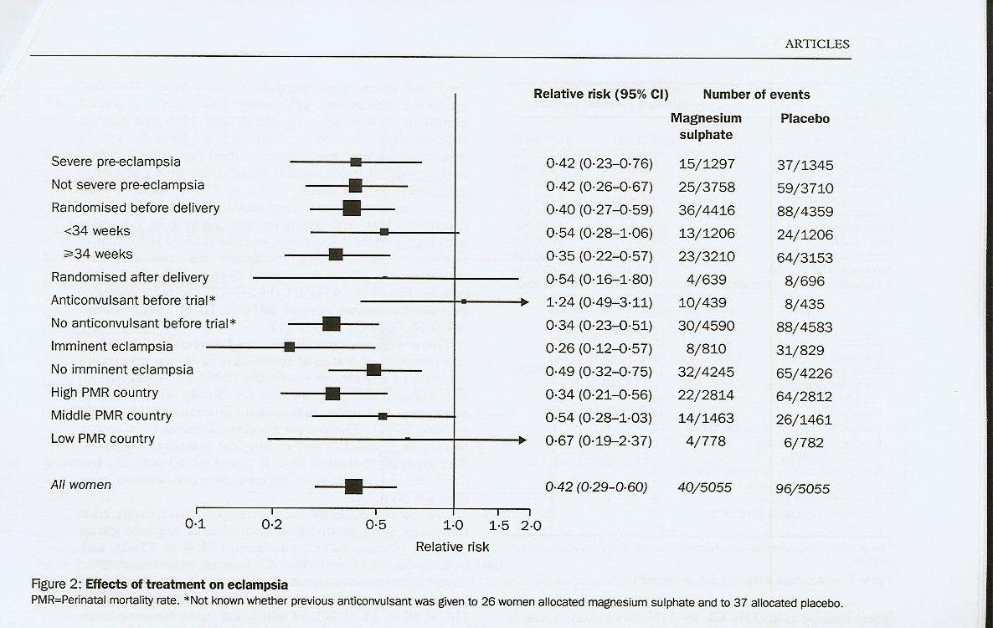

In the Magpie study, and in many institutions, magnesium sulphate is only given for 24 hours. If we accept this time limit, its use should be timed for the 24 hours of maximum susceptibility to eclampsia. We all know the only cure for preeclampsia is delivery of the fetus and placenta, which suggests magnesium sulphate should only be started once the labour is in progress, to allow a little time after the birth itself in an attempt to cover those women who develop post-partum eclampsia.

However we need also to look beyond outcome measures of eclampsia itself, particularly in the western world where the prevalence of eclampsia has declined, but the morbidity of those with severe preeclampsia or eclampsia remains. Complications such as stroke, pulmonary oedema, liver haematoma and renal failure are not improved by magnesium sulphate, yet remain important causes of morbidity and mortality in this group.

From Magpie Collaborative Group²

In conclusion, unlike the answers to “what anticonvulsant should we use?” or “when should it be started in eclampsia?”, there is no single evidence-based answer to the question “when should anti-convulsants be used in pre-eclampsia?”. That answer will depend on the patient population, the degree of antenatal care, the ability to admit and closely monitor patients, the availability of neonatal beds, and the individual clinician’s estimate of when the potential harms of a policy of magnesium sulphate prophylaxis in pre-eclampsia outweigh the benefits. I believe this uncertainty will remain until the pathophysiology of gestosis is completely delineated.

References
1. Which anti-convulsant for women with pre-eclampsia? Evidence from the collaborative eclampsia trial. Lancet 1995; 345:1455-63.
2. Magpie Trial Collaborative Group. Do women with pre-eclampsia, and their babies, benefit from magnesium sulphate? The Magpie Trial: a randomised placebo-controlled trial. Lancet 2002; 359:1877-90.
3. Duley L, Gülmezoglu AM, Henderson-Smart DJ. Magnesium sulphate and other anticonvulsants for women with pre-eclampsia. The Cochrane Database of Systematic Reviews 2003, Issue 2.
4. ACOG. Diagnosis and management of preeclampsia and eclampsia. ACOG Practice Bulletin 2002; 33:1-14
5. Walker JJ. Pre-eclampsia. Lancet 2000; 356:1260-65
6. Katz VL, Farmer R, Kuller JA. Preecalmpsi into eclampsia: towards a new paradigm. Am J Obstet Gynecol. 2000; 182:1389-96.
7. Douglas KA, Redman CWG. Eclampsia in the UK. . BMJ 1994; 309:1395-1400.
8. Crowther CA. Hiller JE. Doyle LW. Haslam RR. Australasian Collaborative Trial of Magnesium Sulphate (ACTOMg SO4) Collaborative Group - Effect of magnesium sulfate given for neuroprotection before preterm birth: a randomized controlled trial. JAMA 2003; 290(20): 269-76
9. Sibai BM. Magnesium sulfate prophylaxis in preeclampsia: Lessons learned from recent trials. Am J Obstet Gynecol 2004; 190:1520-26.

