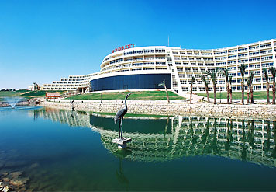
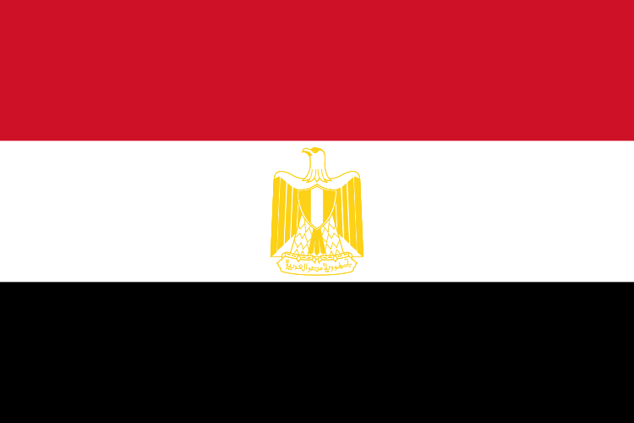
the 12 th
Annual International Congress
" Women: Health, Happiness & Prosperity"
30th-31th may, 2007
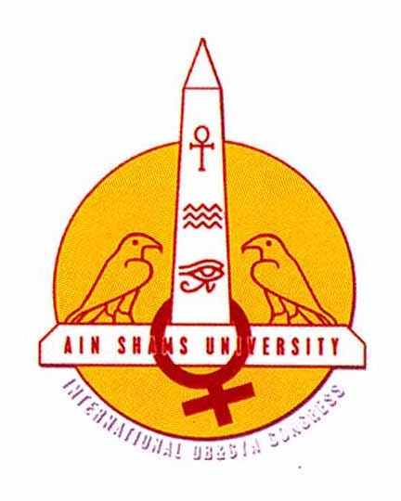
Post Congress Awards
Awarded Session Chairpersons

Session I
Plenary 1
Session II
Session II (A)  Reproductive Medicine | Session II (B)  General Topics
Session III
Session III (A)  Gynecological Oncology | Session III (B)  OGASH Session
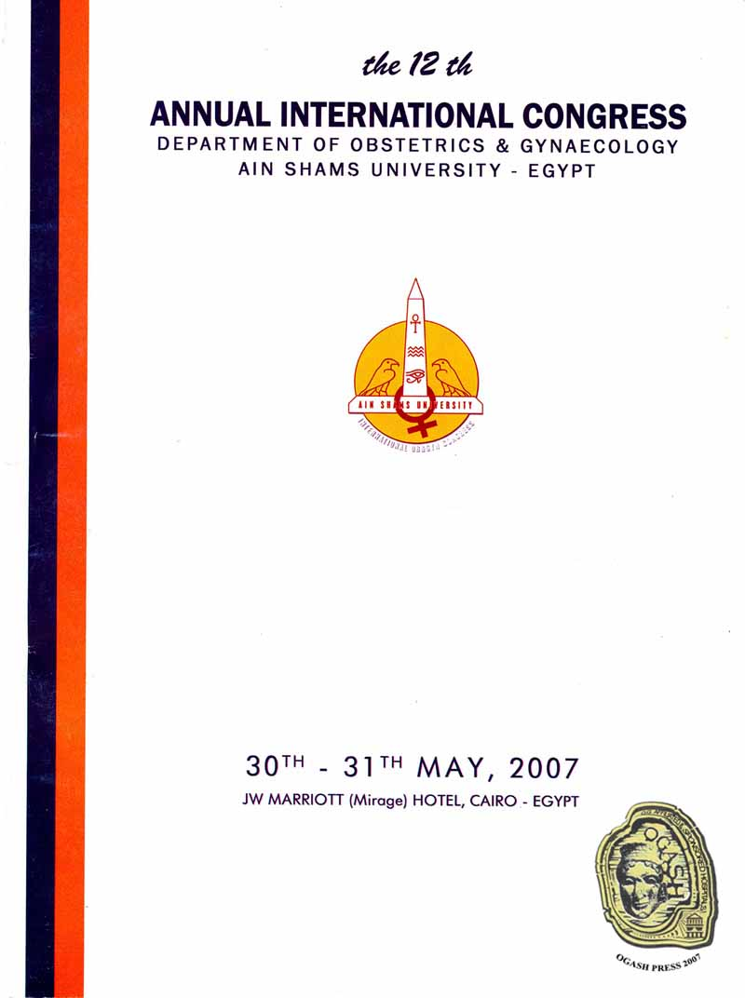
Session IV
Plenary 2
Session V
Session V (A)  Urogynecology | Session V (B)  General Obstetrics
Session VI
Session VI (A)  Egyptian German  Society Session  (Sponsored by Solvay) | Session VI (B)  General Gynecology


