The Egyptian Group Of
Organization Gestosis &
OGASH Supporters (EGOOS)
Introduction;
After foundation of the Organization Gestosis in Basel, Switzerland in 1969 and after the election of Professor H. El-Kabarity as the President of this Organization in Cape-Town, South Africa (2000); another society has been founded by Professor Avtandil R. Chkheidze and named Organisation Gestosis Affiliated & Sponsored Hospitals (OGASH) in Tbilisi, Georgia(2003), aiming at spreading the trend of treating Gestosis in hospitals and specialized units to get the best quality of women's reproductive health.
In Egypt, Gestosis has high statistical ratio. It is one of the leading causes of maternal mortality (50%). Gestosis may increase perinatal mortality 100 times.
So, Egypt was one of the earlier founders of Organization Gestosis Affiliated & Sponsored Hospitals (OGASH). Professor Nabegh El-Mahallawi was chosen as a coordinator of this society in Egypt since 2005.
These medical aims were to be widely spread allover Egypt. So, the need for declaration of The Egyptian Group Of Organisation Gestosis & OGASH Supporters. It includes all the following members:
1- Ain Shams University:
• Department of Obstetrics & Gynecology:
- Prof. Mohamed Nabegh El-Mahallawi: OGASH Coordinator in Egypt & Chairman of the Dept.
- Prof. Abdel-Megeed Ismail: Member of Board of the O.G. in Egypt.
- Prof. Ali Elian Khalaf-Allah.
- Prof. Alaa El-Itribi.
- Prof. Sherif El-Ghitani: Vice President O.G. 19924993.
- Prof. Ashraf Kortam.
- Prof. Mourad El-Saeed.
- Prof. Saeed Mohamed Tohami.
- Prof. Maged Abu-Saeda.

- Prof. Ahmed Rami.
- Prof. Amr El-Shalakani.
- Dr. Ahmed Hamdi.
- Dr. Hassan Mohannad.
- Dr. Mohamed Taha.
- Dr. Tamer Borg.
- Dr. Mostafa Ibrahim.
• Department of Clinical Immunology:
- Prof. Mona Wahba.
- Dr. Rania Hamdi.
• Department of Anaesthiology & ICU:
- Prof. Reem Hamdi: . Critical Care
Anesthesia & Vie President of the O.G.
2- Menia University:
- Prof. Mostafa Eissa: Chairman of the Ob./Gyn. Dept.
- Prof. Sayed Kafafi.
3- Al-Azhar University:
- Prof. Ezzat Sakr.
- Prof. Abdel-Kareem El-Hemali.
- Prof. Ibrahim Mahrous
4- Assiut University: -
- Prof. Mamdouh Shaaban.
- Prof.Hossam Thabet.
5- Upper Egypt (South Valley) University:
- Prof. Osman Abdel-Kareem.
- Prof. Gamal Habeeb Ilias.
6- Tahta University:
- Prof. Gamal El-Deen Youssef El-Kholy.
- Prof. Mohamed Nabeeh El-Ghareeb.
7- Mansoura University:
- Prof. Assem Saber El-Molla
- Dr. Mohamed El-Sayed.
8- Alexandria University:
- Prof. Sameer El-Sahwi: President of O.G. during 2002-2003.
- Dr. Reham Morgan.
- 9- Damieta:
- - Prof. Mohamed El-Sherbeeni.
- 10- Ministry Of Health & Population:
- - Prof. Nadia Ragab: General Manager of
Development & Research Administration.
- 11- Banha University:
- • Prof. Mohsen Nosair: Chairman of Dept. ofOb./Gyn.
- Membership still open for all categories either doctors or non-doctors.
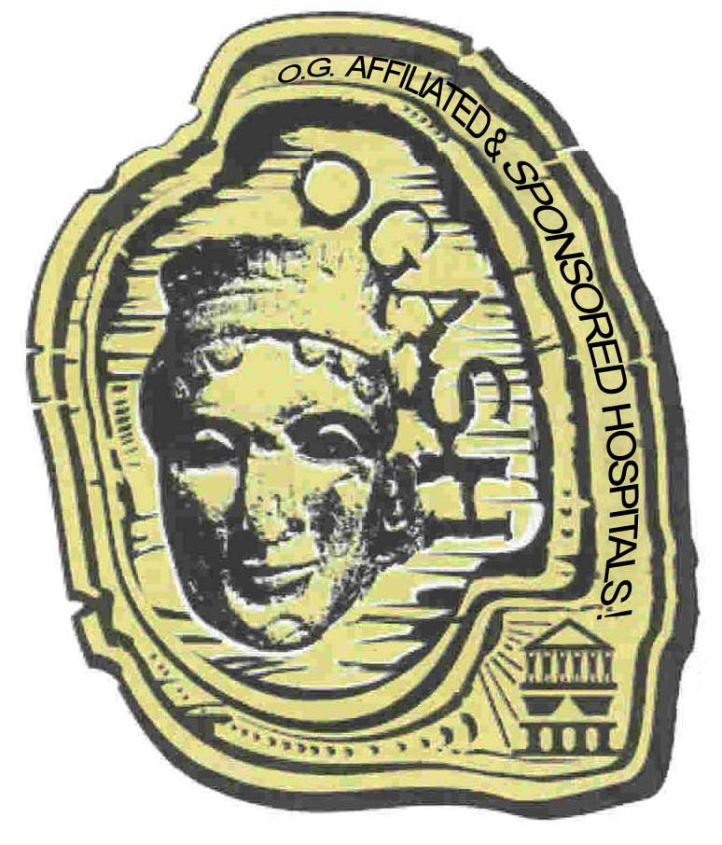

EGOOS

EGOOS

